**UX Review of Change Lab:**

**Website:** <https://changelab.studio>

**Goal:** Goal is to get users to register for courses

**Buyer Thoughts:**

* Need strong CTAs and messaging, SEO, mobile responsiveness. The target audience is entry to mid-level nonprofit staff and managers looking to increase professional growth (their skill set and experience) in order to meet their nonprofits objectives and goals. Change Lab offers advancement through interactive engagement - growing doesn't have to be a pain - it's a game! It can be fun! CTA should be to sign up for appropriate courses to meet their objectives. website is: [https://changelab.studio/.](https://changelab.studio/) Right now the site doesn't showcase how it will positively change their life - able to meet nonprofit goals, career advancement, Benefits need to be highlighted: help professionals develop valuable skills within their field and position them as an authority to clients and others in that field, develop new skills or enhance current skills, stay relevant, etc.
* Would also like to condense the pages with anchors or whatever you think. Thinking should be About - with Media and Blog/Journal under, Advancement (Programs (courses), Coaching, and Virtual Experience within.

**Review Information:**

This review is based on the heuristic evaluation. The website design lacks the call of action buttons, page navigation, color, design consistency, and lack of design similarity, which is very important factor and help the user to achieve goal quickly and give them a sense that they are already familiar with the website. I appreciate the use of gamification design elements. This idea is new and help you engage the user.

I have suggested the UI design in some of the screenshots apart from that I also presented a lo-fi of the main home page to get you an idea how you can redesign the homepage to make the courses, coaching, virtual experience, and other pages more accessible for the users. The 3 sitemaps are also suggested to improve the user flow and user navigation (website pages navigation). Apart from that few design inspiration I showed from the competitor websites which will be helpful to improve the UX of the website.

**My Feedback:**

1. As you guys are trying to cultivate gamification in the teaching process of the courses. So far, I understand that you have the “Hovering over the bulbs to find out the ideas” design on the home page. Using gamification is a great idea to introduce and engage user on your website but the current game idea is so basic, unattractive and demand more of user focus and attention to understand the process 🡪 this led to confusion in users, and they may acquire more time to understand.

For home page, find some other attractive game ideas, a bit advance to attract the audience. Like Mario running on the wall and each milestone like create account, login, register to course etc. should be coins or rewards. A user presses the spacebar/tap on Mario to run the Mario on the wall and use the upper arrow key to get the rewards. (A feedback msg will be displayed to let the user know what to do) or a user can directly click on the reward or coin to achieve goal.

A mini game that is more attractive and designed according to the age group of your audience is recommended.

OR in case if you still want to go with the bulb ideas. Add some of the animation in it. Bulbs get highlighted, colored or change positions, text should be on the bulbs. Something different than the current way of representation.

In case if you want to introduce gamification in your website. Do add them in the courses, you already did a pretty good job. Apart from that you can also add scores, timer to complete a course, create a progress map where you show the users who completed courses with you along their achievements or scores etc.

1. Your main goal is to get the user register for the courses, but that information is not visible on the main home page and on the whole page.

* Show menu bar on the header where you show the main pages. Or on the left or right side of the screen (page).
* Keep each section information on the home page according to your goals and give a button which leads the users to their desired pages.
* Instead of putting tagline “Innovation in nonprofit education for the greater good” in the header make it a part of logo or display it as a message on the home page.

1. The header and the page titles are getting mixed. It seems like the header is occupying a large size on the screens.

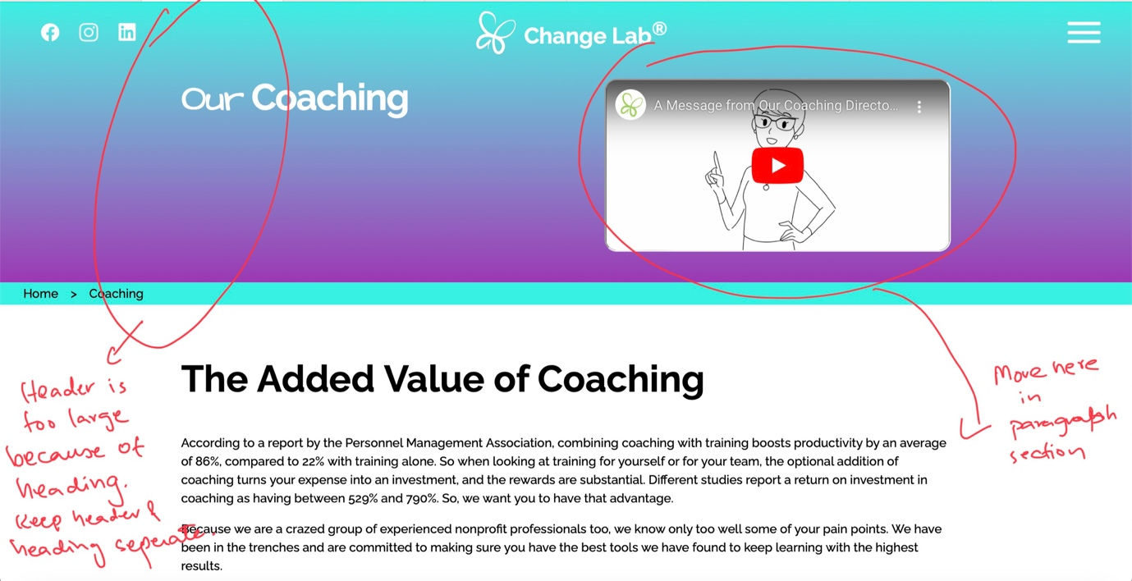

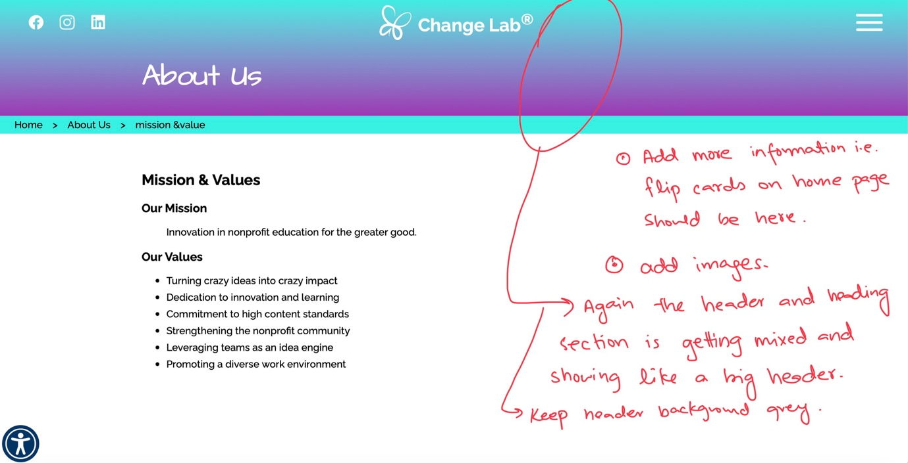

1. The header of the home page is grey whereas the remaining pages is colored and showed grey while scrolling. From my opinion the home page header is great. The rest of the pages header is confusing and not giving an unattractive look.
2. Contact us page header is change. The rest of the pages has gradient colored header whereas on contact us you have displayed an image. To keep the look of the whole website consistent, it is important to keep the header, footer, font size, color of buttons, action buttons shape, headings, background color, and icon style and colors etc. same across all the pages.

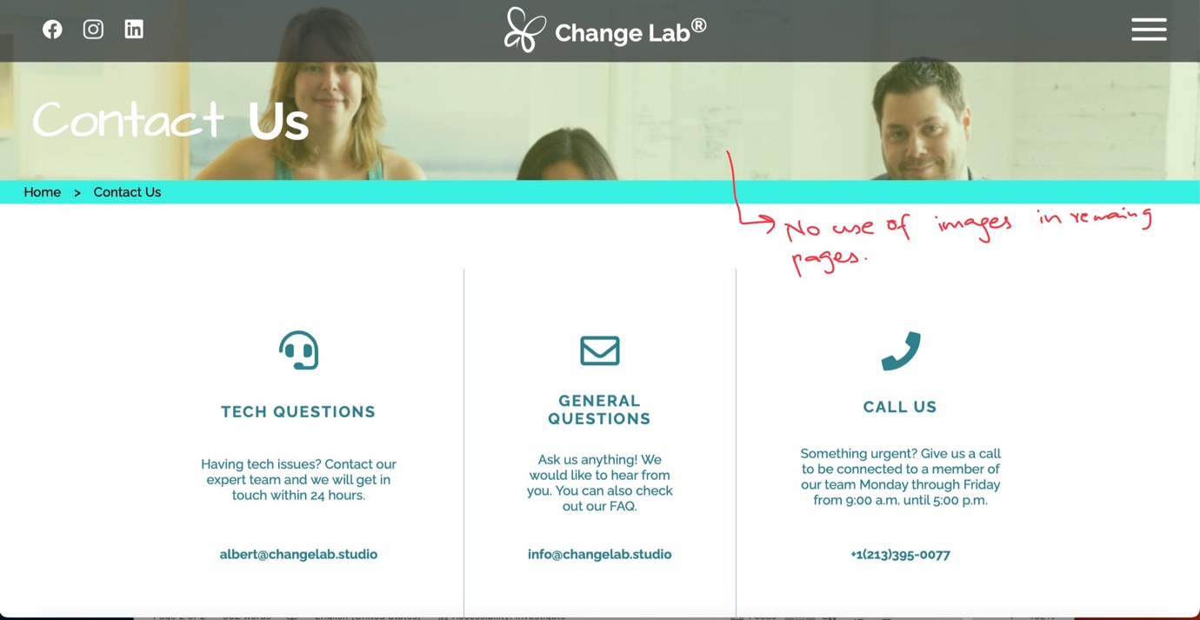

1. Add more information in the footer i.e., sitemap (pages link with name)

About us

Courses

Virtual experience

Coaching

FAQs

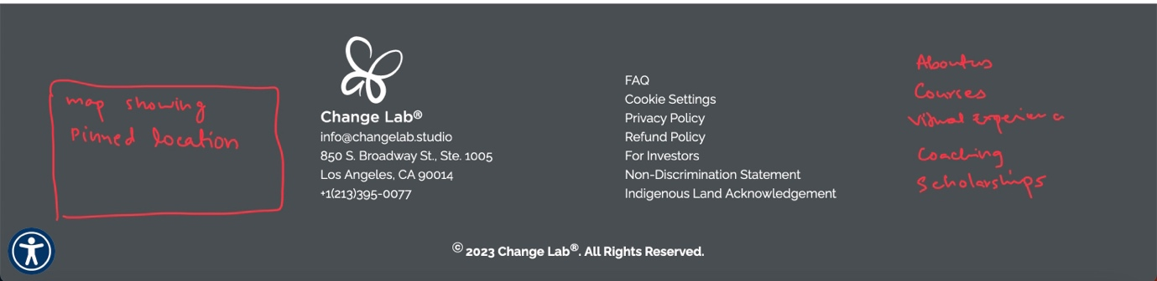

1. Lack of call to actions buttons. Add buttons along with each section on the home page. Add pages as navigation bar in header, add the pages in the footer.

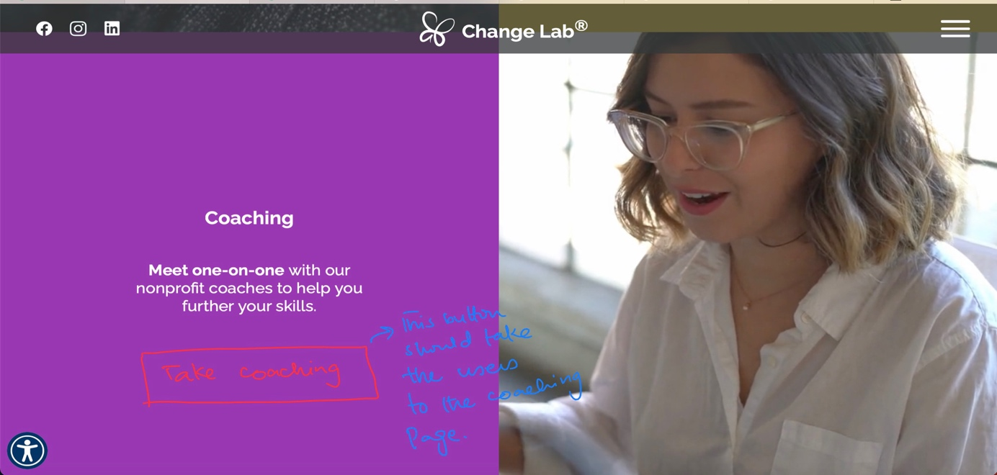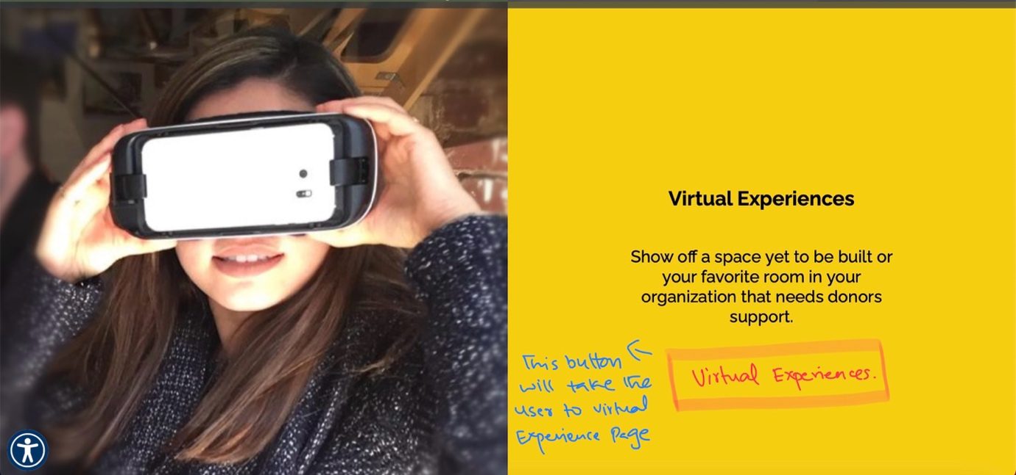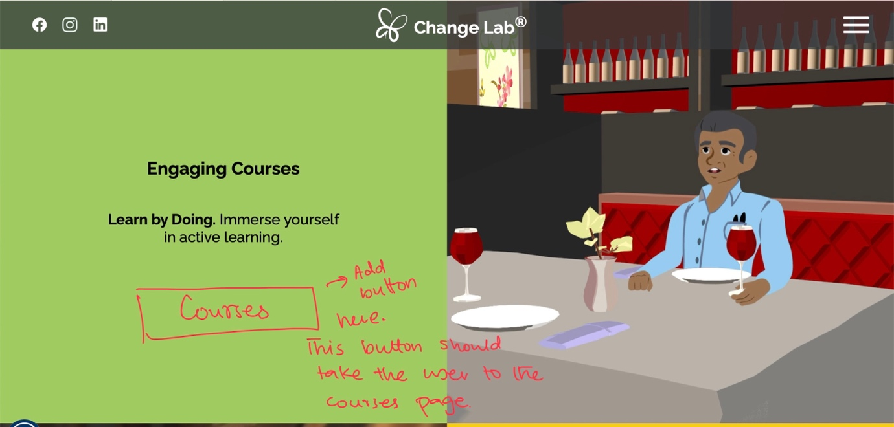

1. The style of the start button on the courses page is not good.

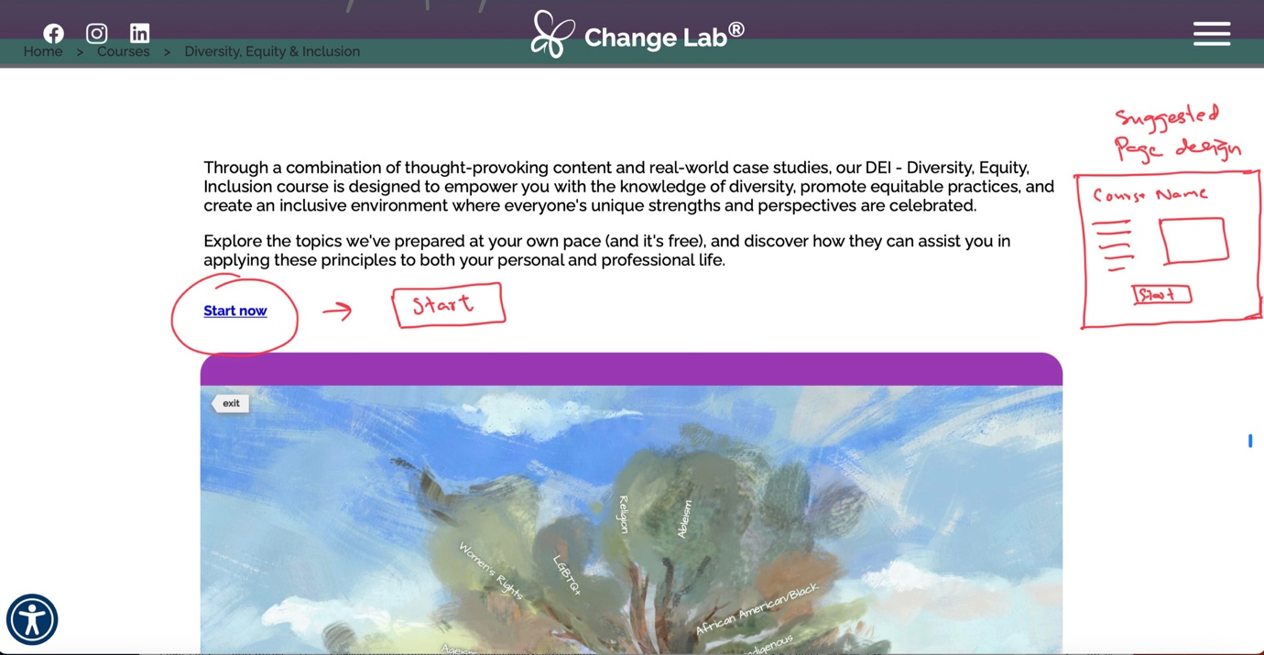

1. The flip card on the home page is very compact and contain useful information. Do add this information in about us or match the flip card colors with the rest of the website color theme.

**Suggested Sitemap:**

Sitemaps help you to design the web pages hierarchy and the navigation bar (which you can show in the header). This information will help you to improve the user flow and user navigation of your website.

I have designed three sitemaps. You can select one which you think better suits your goals.

The most suggested by me is the 2nd sitemap because it is designed by keeping in mind your major goal of registering account and taking course by users. It is more compact not cluttering more options on the home page and combining the information under each category perfectly.

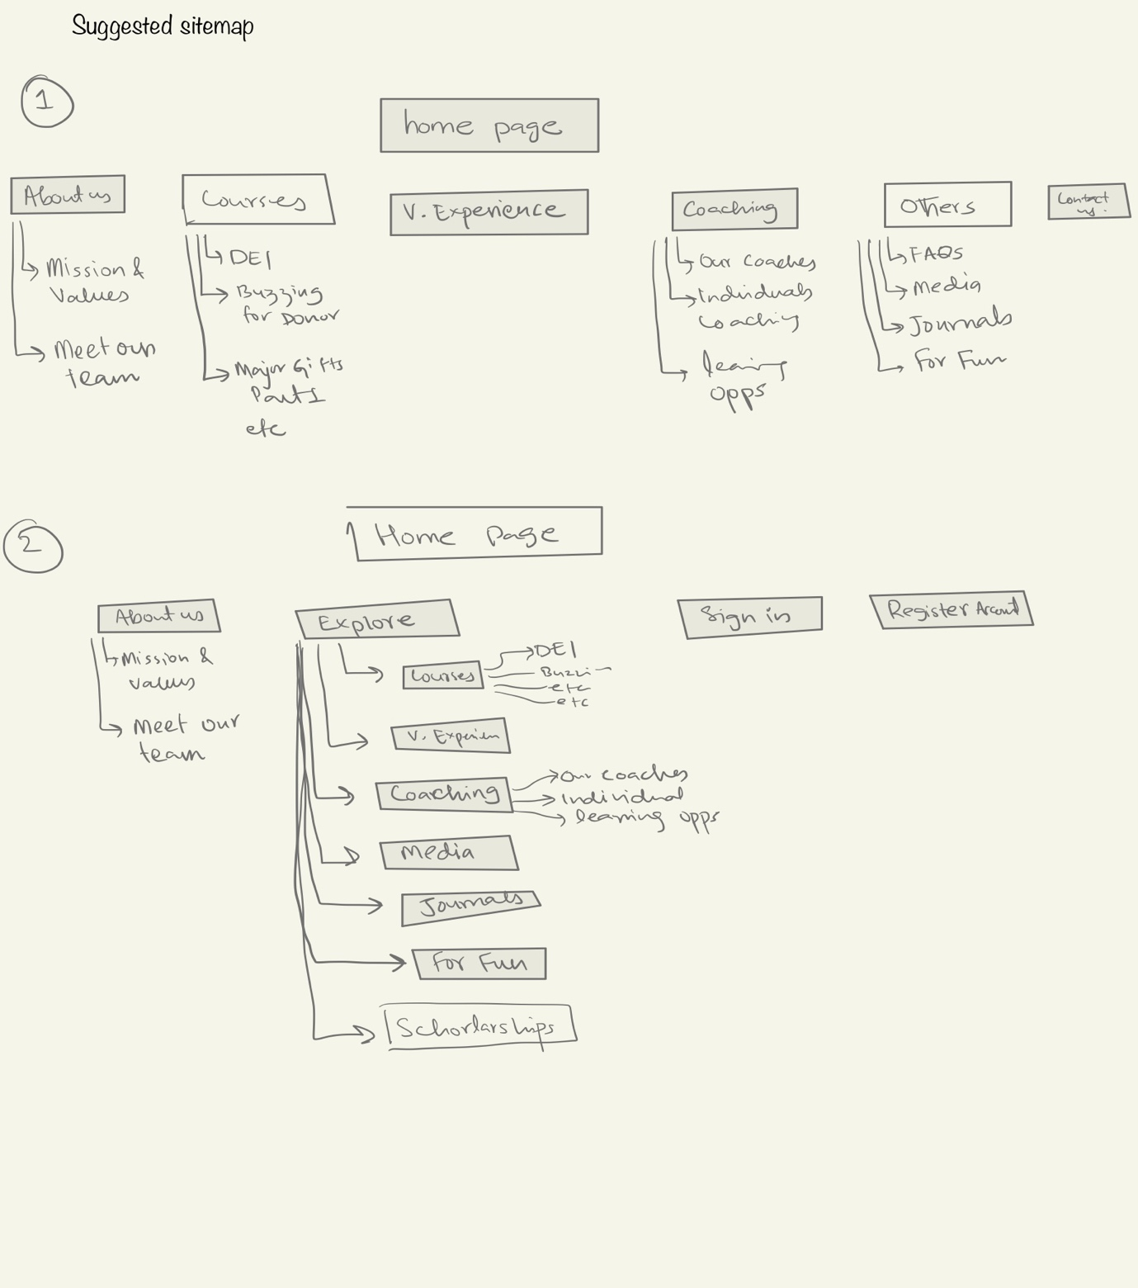

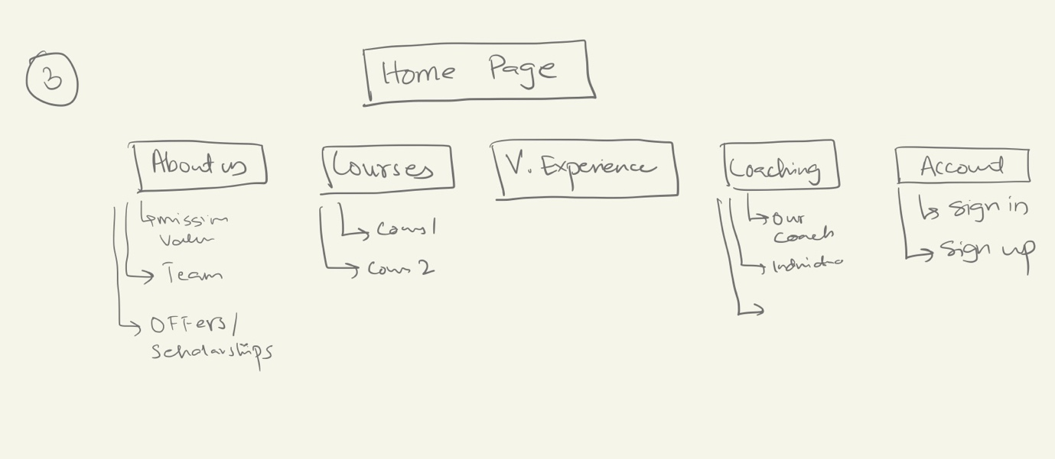

**UX competitive analysis:**

After looking at the different competitor sites that offer the same kind of services, I observed the following things. These things will help us to learn more about the design elements which will help us to achieve our goals:

1.

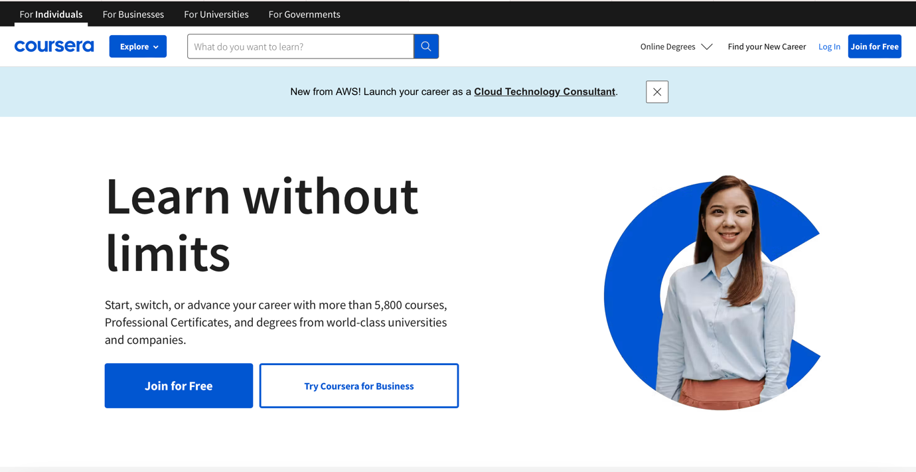

* The explore button. If you don’t want a tradition menu bar in the header you can just add the explore button and in explore you can add courses, coaching, virtual environment as an option (in the drop-down menu)
* You can add something on the main homepage like “lets grow together and help each other grown and uplevel their work environment ,,,,,,,, etc. “ and then add the explore button

2.

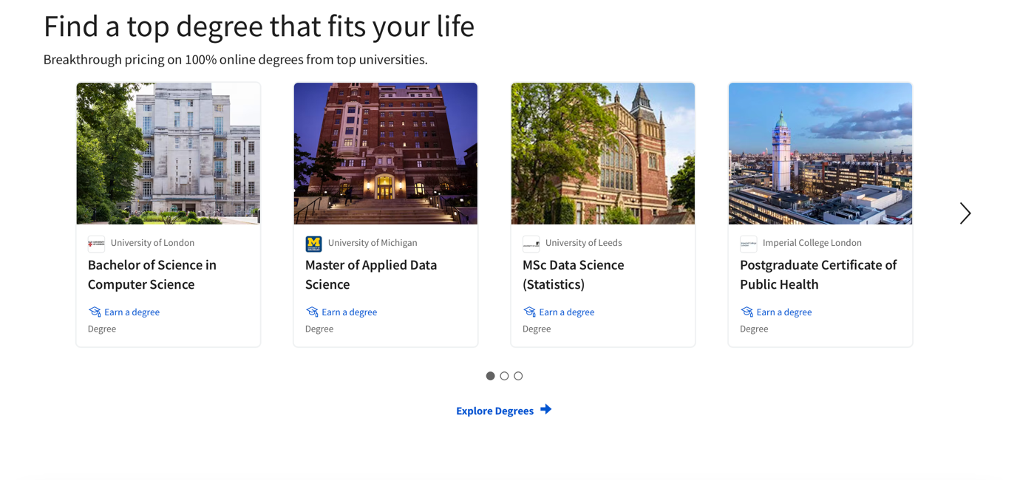

You can also add a section like this on your home page or on the courses page. The cards are so aligned and compact. You can put start button on each card to get the user start or explore more about the course.

3.

<https://www.skillsoft.com>

Skill soft home page is showing a slider on scroll which change information and engage a person. You can also do this and display your major goals/concern on the main home page.

But again, if you still want to go with the minigame make sure to add some attractive and engaging game.

4.

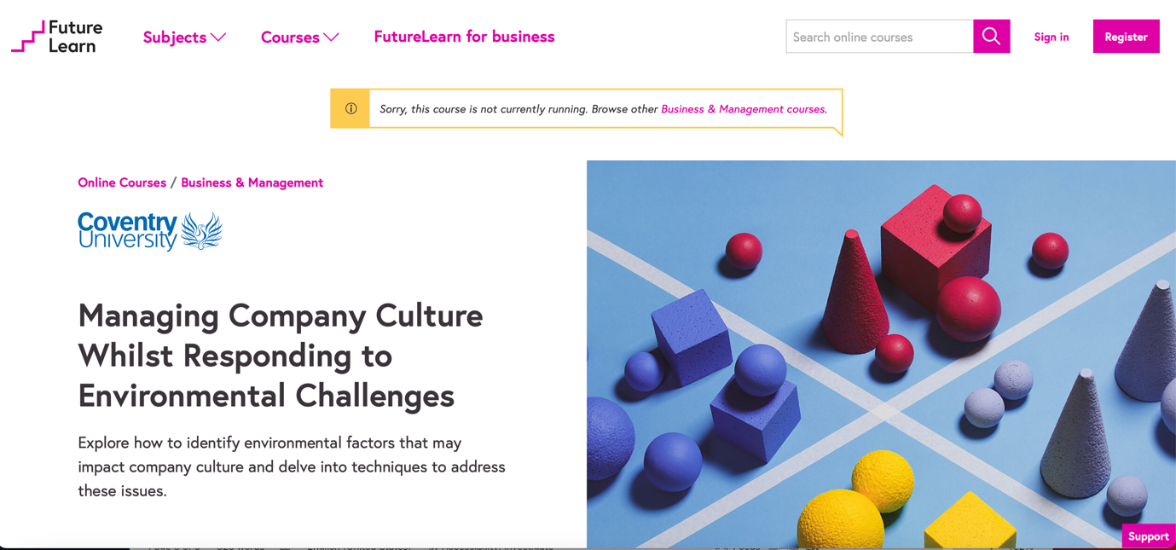

This is placed to give you an idea about designing a navigation bar in the header that lead the user to main goal quickly and efficiently.

You can keep the courses, coaching, virtual experience on the left side along with logo and sign in or register to the right side.

This will help the user to accomplish the task easily. Especially registering for courses and creating account or sign into the account.

**Suggested UI (Lo-fi):**

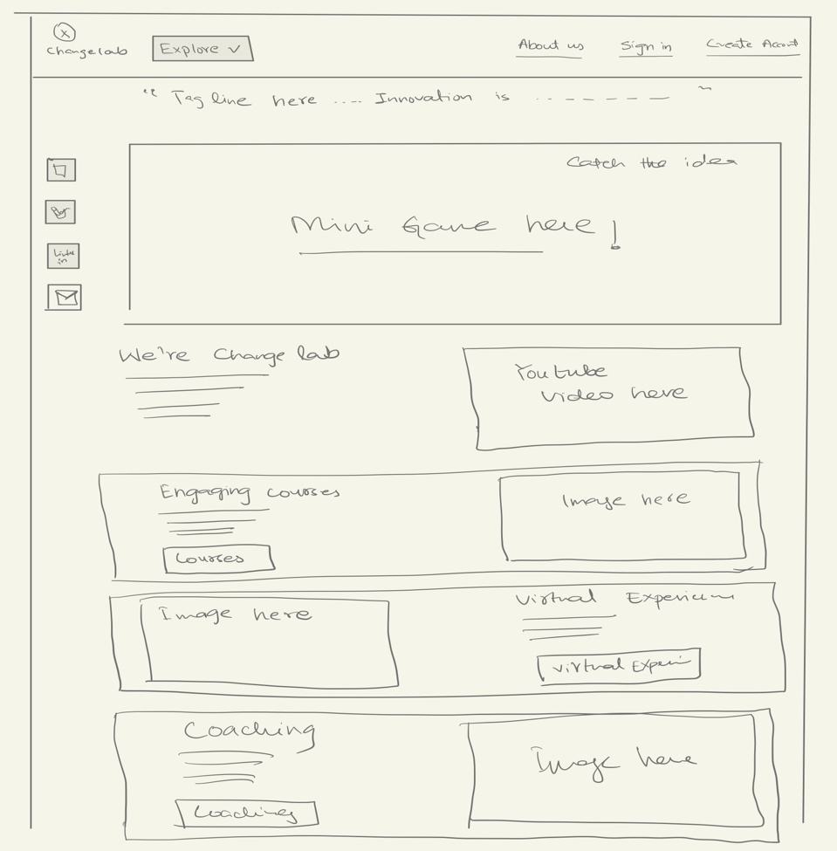

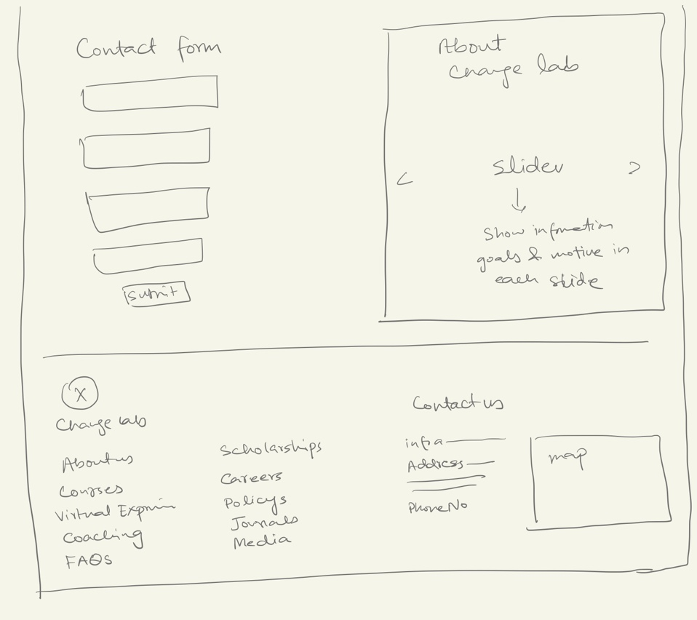

This lofi screen is just designed to give you an idea, how you can manage to display the information on the home page.

The Explore button is a drop down menu which will show the options 🡪 Courses, Virtual experiences, Coaches, Scholarships, The fun, Journal, Media

**Summary:**

1. Color consistency: Keep the color of header and footer, font, flip cards, and buttons same.

Solution: Select a color palette (means for heading select a color, for background, header, footer, and text. Make sure to select color of same color family or in contrast) and font sizes for heading and paragraph text.

1. Add buttons in the suggested section of home page and course page. The more you will add buttons and link of pages in the header and footer as navigation bar, the more chance user can click on them and reach their destination. The more options, the more it will be easy for the user to accomplish task. Also, the repetition of such information and buttons will take the user to your desired goal.
2. Keep the header and heading section separate. Don’t add any video/image in heading part.
3. Adopt two columns design format for the pages like courses, virtual experience, coaching, mission, and value. Add images to bring attractiveness in them.
4. Add social media links and a contact form on the contact us page.
5. The major reason the current website seems difficult while registering for courses is the lack of the option visibility. Add buttons, navigation bar, or an introduction section instead of mini game to make it easy for the user to achieve the goal/reach the courses.
6. Gamification brings user engagement, attract user, increase user attention towards the task and website. It is very important to use it wisely. Because wrong choice of gamification elements harms the UX of the website too. A mini game is a good idea. But try to make it more attractive and engaging.
7. The content written on the about us page is so confusing. Make it look like a story or add more attention to the details. OR add a video message to deliver your goals and what you guys do and how the courses help the users.
8. There is no search bar present on the website. It is good to add a search bar special in a website offering courses and coaching, so that user can differently type the name of the course of any relevant work to get to the desired page. You can add this in the header (in above lo-fi screen you can add the search bar in the space between explore button and about us).